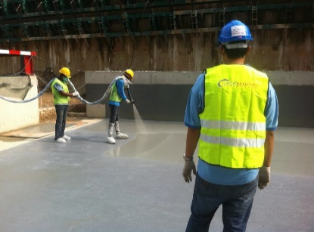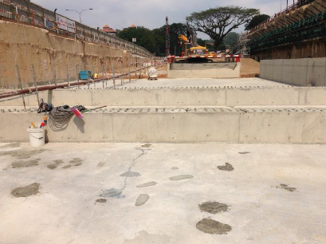

## **Client:**

## NMRT Corporation

## **Distributor:**

## Nukote Industries Malaysia

## **Consultant:**

## AECOM

## **Contractor:**

## MMC-GAMUDA KVMRT (T) SDN BHD

## **Applicator:**

## Nukote Industries Malaysia

## **Area:**

## Total 200,000 m2

## Each Phase 10,000 m2

## **Location:**

## KL Sentral/Malaysia

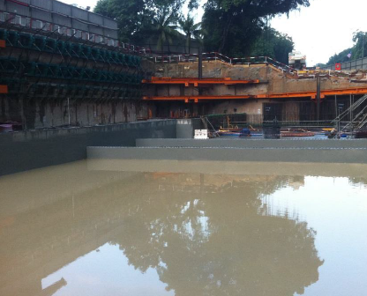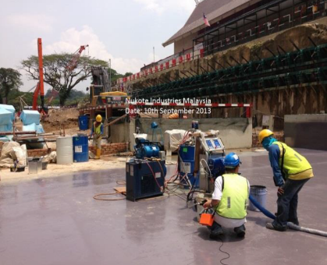

# **Project:**

# Kuala Lampur Metro, MRT Underground Station

# **System:**

# Nukote ST (Pure Polyurea)

# Nukote HLT

# Nukote EP Prime II

# **Description:**

# The project specified the application of Nukote ST (Pure Polyurea) over newly poured concrete. The client’s construction schedule required immediate coating after casting. Nukote HLT followed by Nukote EP Prime II was applied to eliminate vapor entrapment and the potential of pin-holing of the finished surface. The completed coated area was buried within 24 hours after coating application was completed.