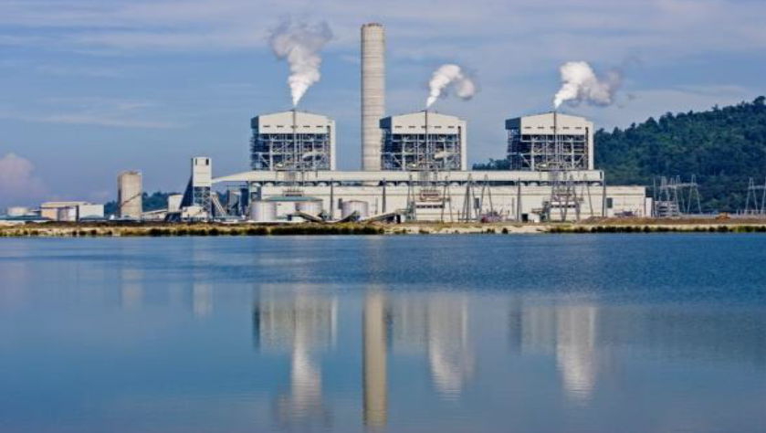

Client:

Tenaga Nasional Berhad

Industry:

Civil Construction

EPC Contractors:

1. ALSTOM POWER SYSTEMS SA
2. ALSTOM (WUHAN) ENGINEERING & TECHNOLOGY CO. LTD
3. ALSTOM SERVICES SDN BHD
4. CHINA NATIONAL MACHINERY IMP. & EXP. CORP
5. CMC MACHIPEX SDN BHD

Sub-contractors:

1. MUDAJAYA CORPORATION BHD.
2. SHANDONG ELECTRIC POWER CONSTRUCTION CORPORATION
3. EVERSENDAI CORPORATION BERHAD

Project:

Manjung 4-1 x 1000 MW Coal-fired Power Plant

Description:
The Manjung 4 power station is expected to be the first ultra-supercritical power plant in Southeast Asia when it is completed in 2015. The 1000 MW coal-fired power station is being constructed under a turnkey contract by a consortium led by the original equipment manufacturer Alstom, in partnership with China Machinery Import and Export Corporation (CMC). The contract was signed with TNB Janamanjung Sdn Bhd, a wholly-owned subsidiary of Tenaga Nasional Berhad, the large state-owned utility.
Manjung 4 will be built on the same site as an existing power station, the three-unit, 2100 MW Manjung Power Plant, which was also constructed by Alstom and began delivering power in 2003. Located in the Manjung municipality the plant is built on a reclaimed island off the western coast of the state of Perak, around 10 km south of Lumut and 288 km north of Kuala Lumpur. The island is also home to the Lekir coal terminal, where coal to power the existing Manjung plant is imported. This terminal will also supply the fuel for Manjung 4.

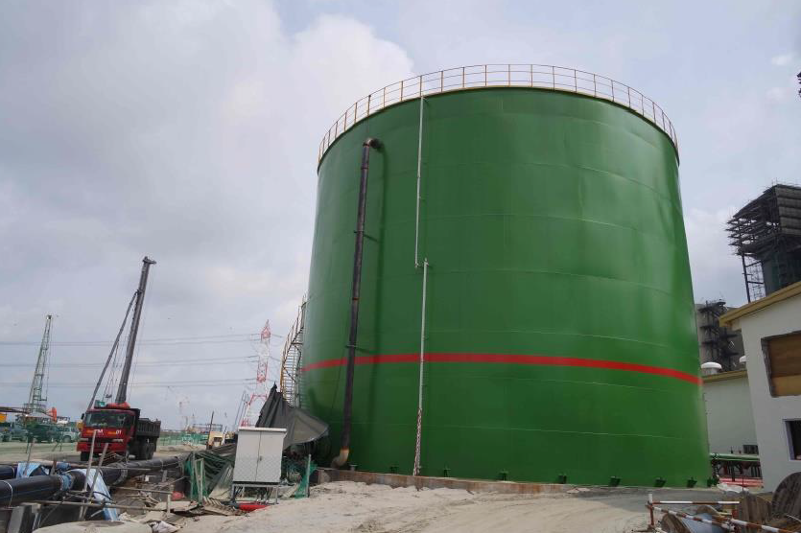

Employer’s Engineer:

TEPSCO

Applicator:

Nukote Industries Malaysia

QA/ ITP Manufacturer:

Nukote Industries Malaysia

Application Type:

Chemical resistance coating

Area:

10,000 m²

Location:

Manjung, Perak/ Malaysia

Nukote Industries Coating Systems became involved with the project in early 2013 at the request of Mudajaya Corporation Bhd and Shandong Electric Power Construction Corporation (SEPCO II), to assist with the design and approval process for a chemical resistance coating system in the power station.
Nukote Industries Coating Systems worked closely with the consultants and engineers to successfully specify the following coating systems which were later supplied and installed in the project by Nukote’s qualified coating applicators. The following applications and their product specifications were as follows:

Internal Painting of Water Tank
- Filtered Water Tank – Nukote ST @ 2.5 mm
- Primary Demineralized Water Tank – Nukote ST @ 2.5 mm
- Reverse Osmosis Water Tank – Nukote ST @ 2.5 mm
- Demineralized Water Storage Tank – Nukote ST @ 2.5 mm
- Fire Fighting Water Storage Tank – Nukote ST @ 2.5 mm

Internal Painting of Water Tank
The project involved in a confined space (internal tank) with only one opening at the side of steel water tank. Confined space work has to comply with the local regulation. Force ventilation was introduced to provide a safe working environment. Regular check for oxygen levels and other hazardous gases was conducted by a qualified confined space assessor. Applicators working inside the tank had relevant certification by the local authority. The internal steel tank surface preparation was done by sandblasting using PU ball attached with vacuum.
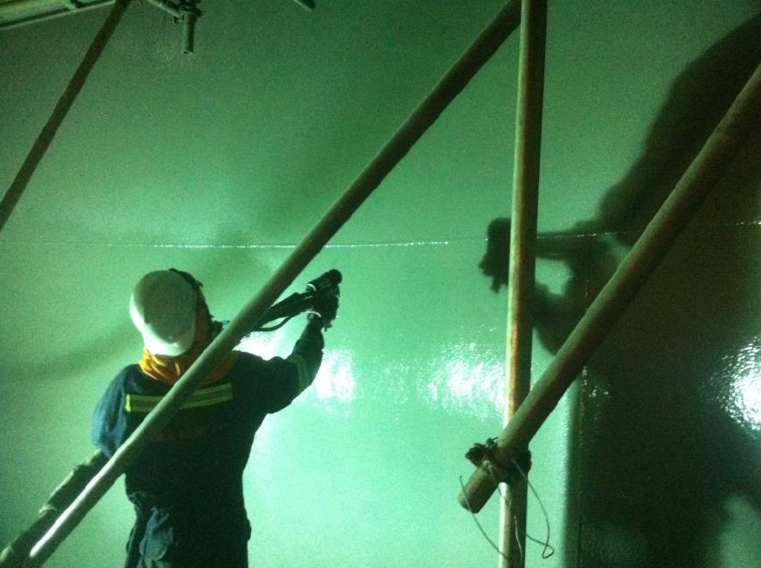
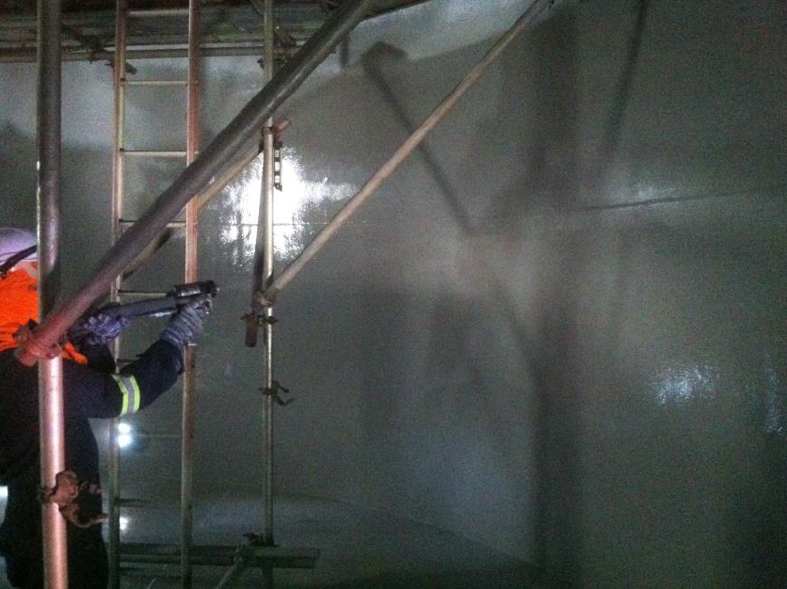

The system applied was Nukote Metal Prime II at 60 microns over prepared substrate with Nukote ST at 2.5 mm. The client’s primary requirements were Potable Water Certification which is the SPAN Certificate (SPAN/PP1/300-10/608/B/W-1), strong coating impermeability and good properties such as high elongation, tensile strength etc. Final inspection such as dry film thickness (DFT) and holiday testing was tested on the tank surface. DFT check is required to ensure specified thickness is applied accordingly while holiday testing is applied to ensure no pinholes are detected in the tanks before handing over to the client.

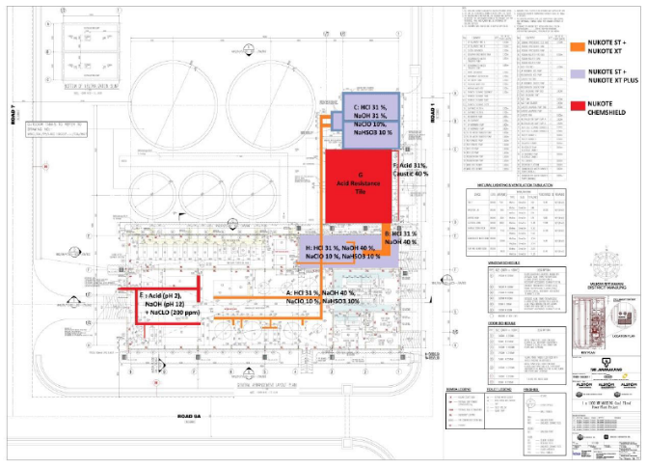
Cycle Makeup Treatment Plant

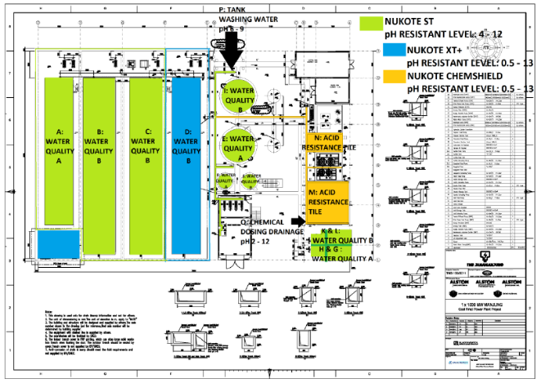
Industrial Wastewater Treatment Plant

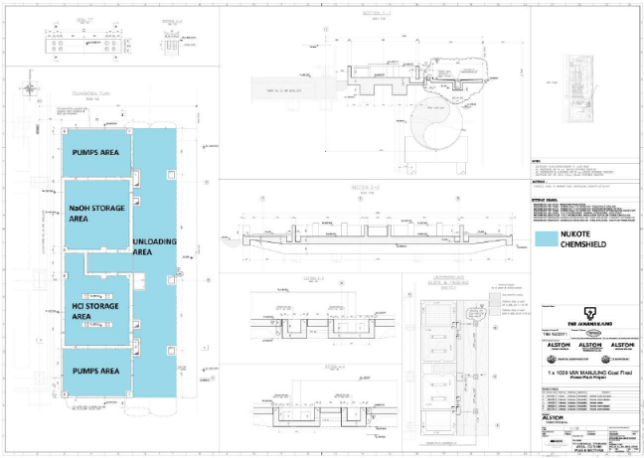
TH-Chemical Storage Area

System:
Nukote ST, Nukote HLT, Nukote EP Prime II, Nukote XT Plus, Nukote Chemshield

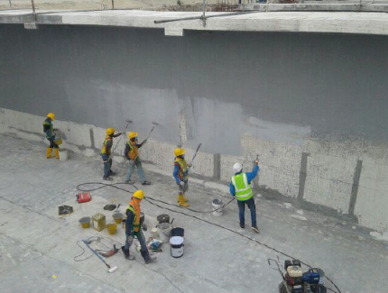
Nukote Industries Coating Systems polyurea products were selected and specified by Mudajaya Corporation Berhad as the protective coating system of choice for the Manjung 4 Power Plant at Manjung Perak. Mudajaya Corporation Berhad engaged with Nukote Industries technical teams to prepare the application method statements, quality assurance, inspection and test plans for the chemical coating as specified.
Nukote XT Plus, Nukote Chemshield and Nukote ST were applied in various locations in the project which included the trenches, Chemical Dosing Room, Acid and Caustic Tank Field, Neutralization Sump, Discharge Sump, Sludge Thickener, Clarifier, NaClO and Acid Storage Tank, Chemical Wastewater Pond, Irregular Wastewater Pond, Cold Yard Runoff Wastewater Pond.
Nukote Industries Coating System worked closely with Alstom to specify the suitable application / coating for Chemical Storage Area. This chemical storage area is used to store hydrochloric acid, HCl (concentration of 0-33%) with pH less than 1 and temperature from 18 - 42°C and sodium hydroxide, NaOH (concentration of 0-45%) with pH more than 14 and temperature from 18 - 42°C. Chemical resistance coating is proposed to protect the concrete from chemical attack or to prevent splash from the acid or alkali stored in that area. Hence Nukote Chemshield at 2 mm is proposed as it can withstand a wide range of chemicals and chemical concentration.

